# Q1.

Code:

#include <stdio.h>

int main() {

int num, final;

num = -1;

final = 1;

while (num < 0) {

printf("Enter a number: ");

scanf("%d", &num);

}

for (int i = num ; i > 0; i--) {

final = final * i;

}

printf("%d", final);

return 0;

}

Screenshots:

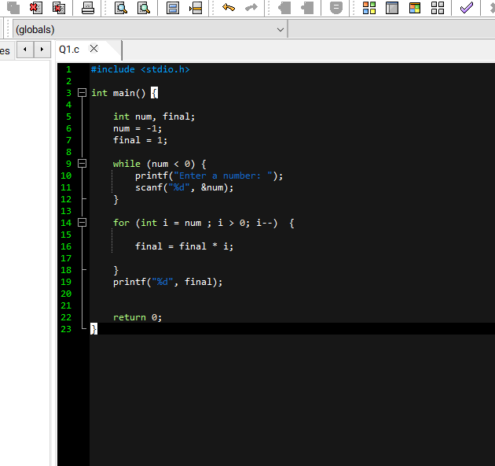

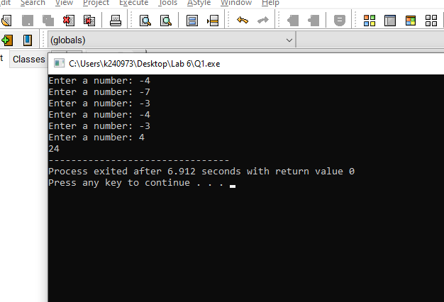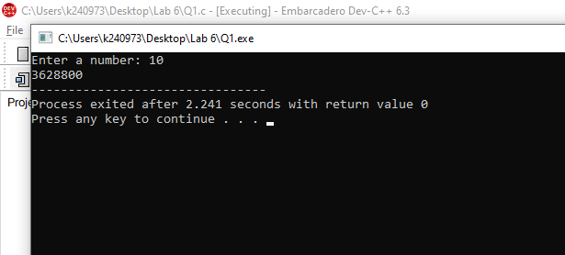

# Q2.

Code:

#include <stdio.h>

int main() {

int num;

int start = 1;

num = -1;

while (num < 1) {

printf("Enter a number: ");

scanf("%d", &num);

}

while (start <= num) {

if (start % 2 == 0) {

printf("%d\n", start);

}

start++;

}

return 0;

}

Screenshots: 